**Bolinas Frank**

**September 6th, 2022**

**AIOps Presentation (26 minutes 53 seconds)**

Hi, my name is Bolinas Frank, you can call me Bo. I am here to talk about AIOps, and how it relates to art. These two things might seem pretty disparate but looking at both together facilitates a more holistic understanding of their symbiosis.

There is this artist Berndnaut Smilde who makes these amazing clouds inside of buildings. He’s been making these clouds for over a decade now. He’s been quoted as saying, "I cannot **really** control the cloud." Meaning that these synthetic clouds that he made only physically last for a few seconds. It’s the photo of the cloud that has the timeless impact. But **we** do have control of the cloud as in data and cloud computing through AI for IT operations, which we are calling AIOps that **has** the ability to persist and span across time reaching into the past and showing us possible futures. Unlike a real physical cloud that may only exist for a few seconds.

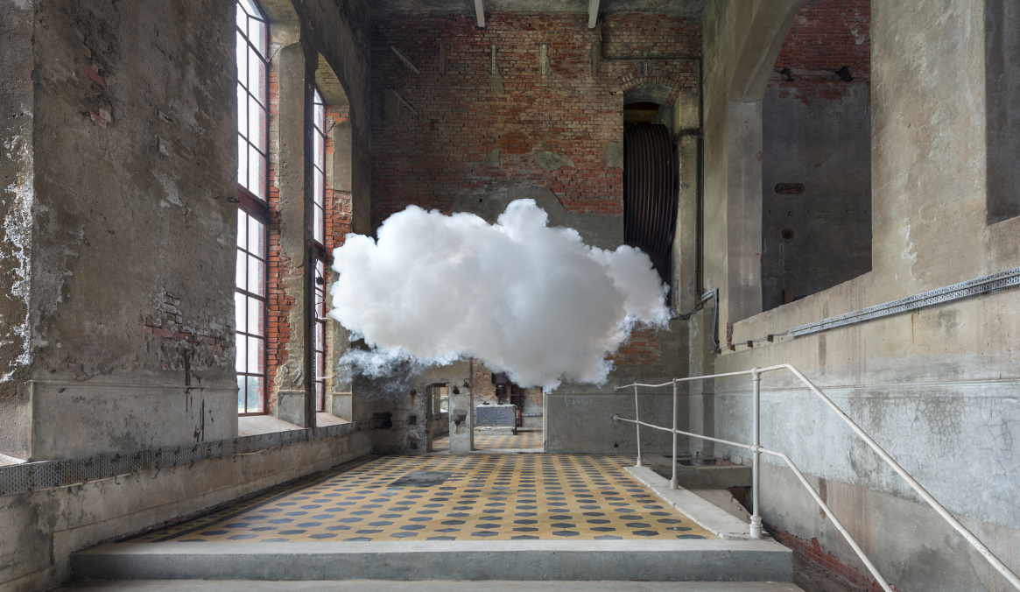

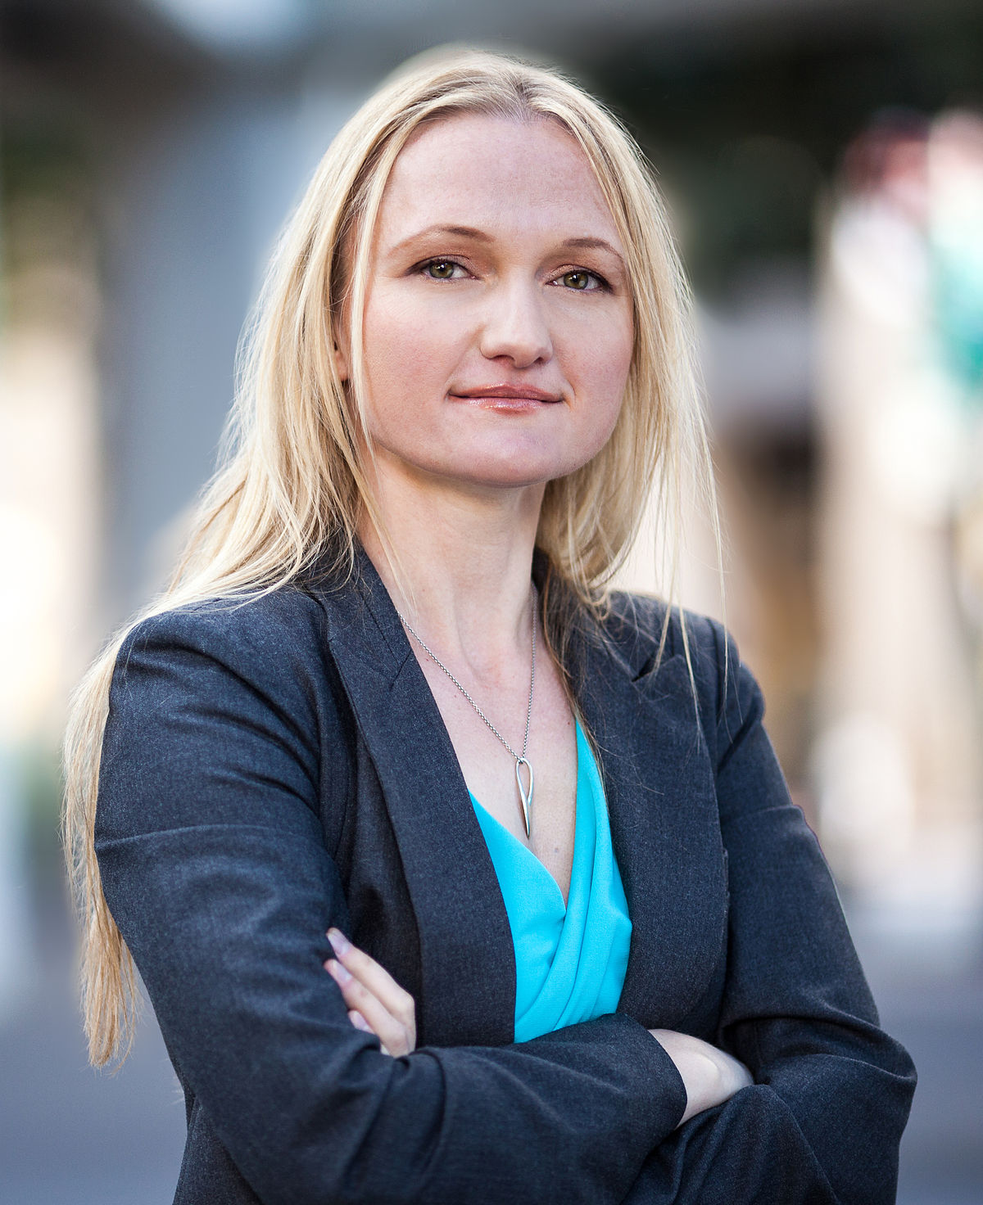

Relating art to science, Lila Tretikov, a deputy CTO here at Microsoft, explains that art and design is one of the best ways to think creatively and imaginatively, and then with the use of science and technology, the vision from scientists and artists can become a reality. She says that it is very important for [scientists] to keep interacting, working with and co-creating with artists because artists can help to ideate and envision tomorrow. We have an opportunity now, especially with AI, to truly have technology assist us, rather than us drive technology. We have the ability to create AI in way that is assistive, and helpful to us, as opposed to destructive.

Demis Hassabis of DeepMind said a lot of the new breakthroughs that are going to come in the next decades are going to come from the intersection of different subject areas where there'll be some new connection that is found between what were seemingly disparate areas. Personally, I think art and AI is an interesting interdisciplinary inquiry drawing on my formal training in art and decades in tech.

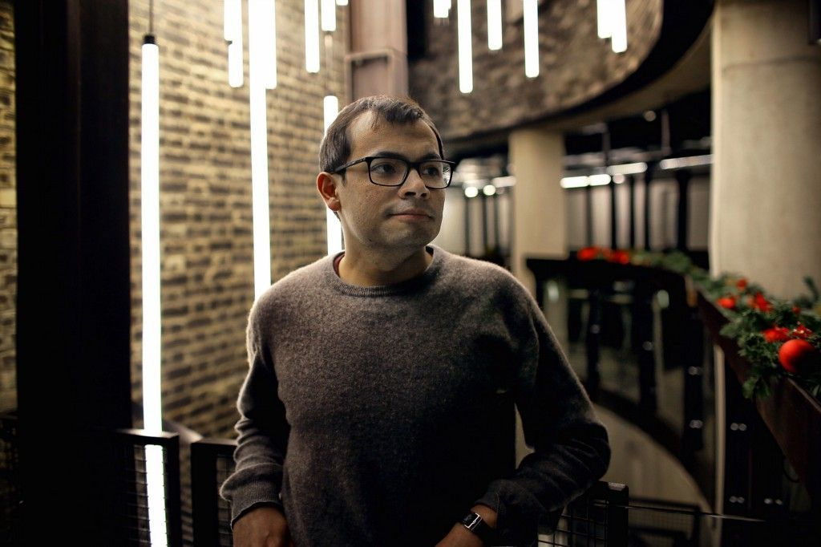

Also at DeepMind, Oriol Vinyals says science fiction has prepared society to start thinking reasonably about certain topics, and for the inevitable research of those topics. There are many important challenges and topics that come with building an intelligent system. We're never going to be fully ready unless people that are not researchers talk about this and we start expanding the people they talk to, to not only include scientific researchers. There are more interdisciplinary groups forming to start asking and really working with researchers on questions because I’m assuming an interdisciplinary topic is not initially where the passion lies when future scientists are getting their PhDs.

Oriol has seen an increased level of maturity in the conferences that deal with AI compared to five years ago from now. The amount of workshops has changed so much it is impressive to see all the topics, including ethics, that come to the surface which is great and if we are too early to address ethical concerns, clearly it's fine because it's a big field and there's lots of people with lots of interest that will make progress and Oriol doesn't believe we're too late.

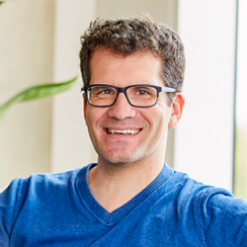

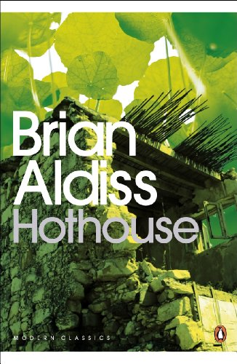

There is value in interdisciplinary work between scientists and sci-fi writers. The writers are important because they focus on thinking outside of the limitations of what is scientifically possible at the moment. Along with writers, visual artists provide the vision of what the future could look like, and there is also a need for scientists to ideate and envision tomorrow. This is Brian Aldiss Hothouse written in 1962 envisioning a future for Earth where plants dominate half the world. This work can be seen as a prediction from the 1960’s for the climate crisis we’re having now.

In this illustration that I created, I was really inspired by the AIoT work the local Seattle company Koidra was doing with smart greenhouses. This is the image used for this year’s KDD AIoT workshop which has been subsequently used in published articles including one by Haining Zheng, the principal data scientist at Exxonmobil, who along with Exxonmobil, is building the future of energy with AI. My thought was to take the greenhouse to scale, with the vision of an endless greenhouse equipped with sensors, and portraying AIoT in drones detecting, diagnosing, and predicting the future of crops. In a way, we are making Aldiss' imagination a reality.

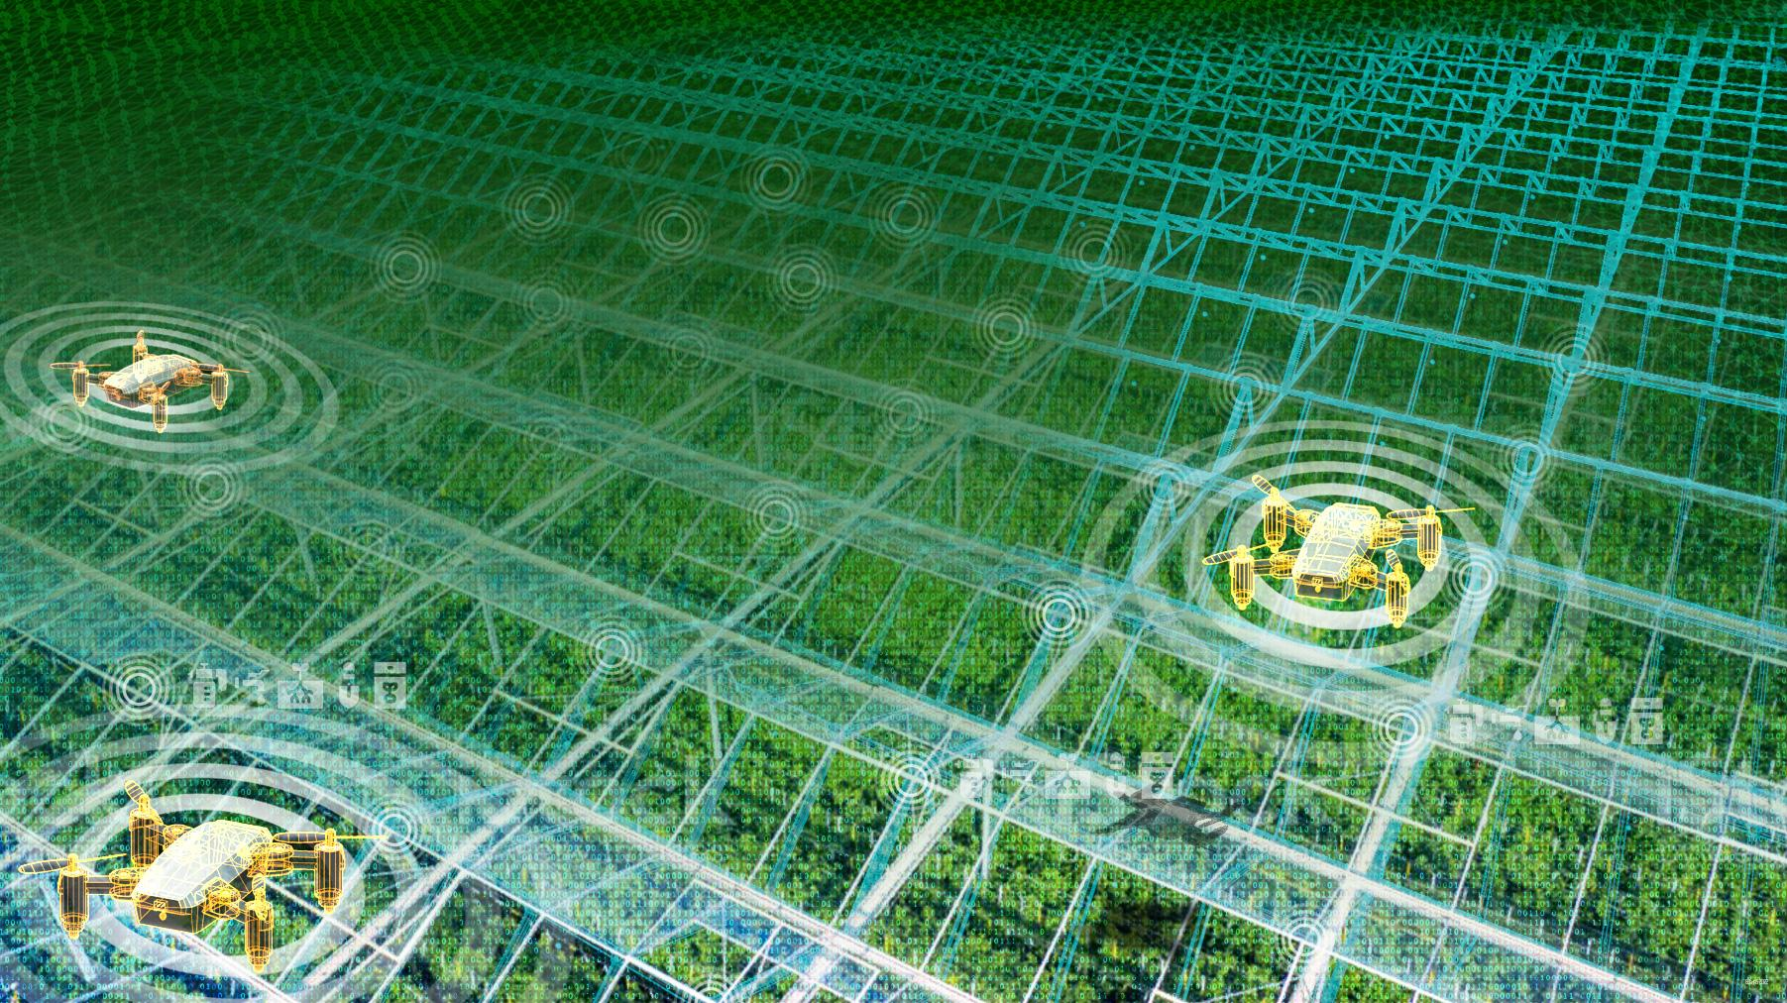

Because I deal with AI and art, it would seem that I would have an opinion about Open AI and DALLE, the AI image generator owned by Microsoft. Which I do have an opinion. I took the previous hero image and ran it through DALLE to get the following, which, interestingly, have a very painterly and more abstract look. More of a raw material with a human touch look, than something that was purely created in blender and photoshop as in the previous image. Although aesthetically more appealing to my eye, the utility of the illustrative function has been lost to something that at the most is suggestive of a drone flying over plants. The last one is particularly interesting in that it looks like DALLE gave the drone its own gravity where its warping the grid.

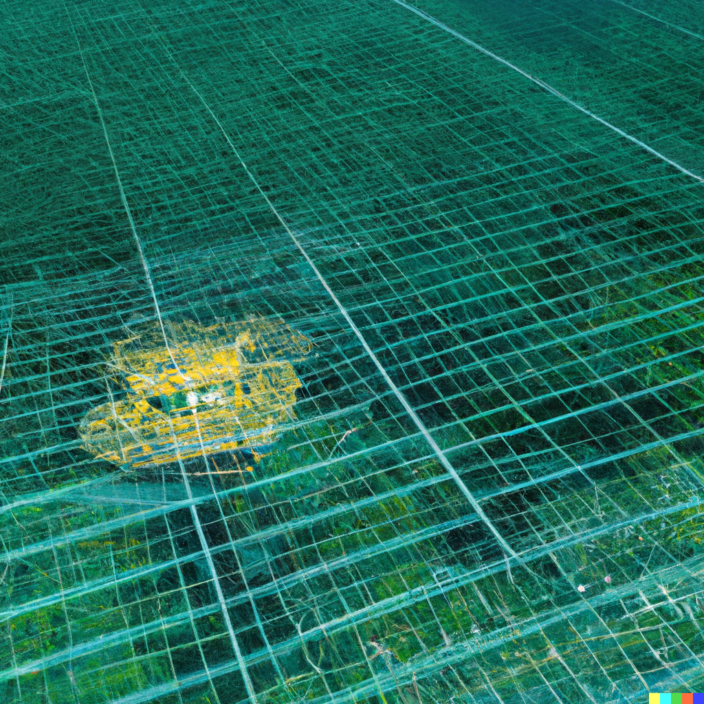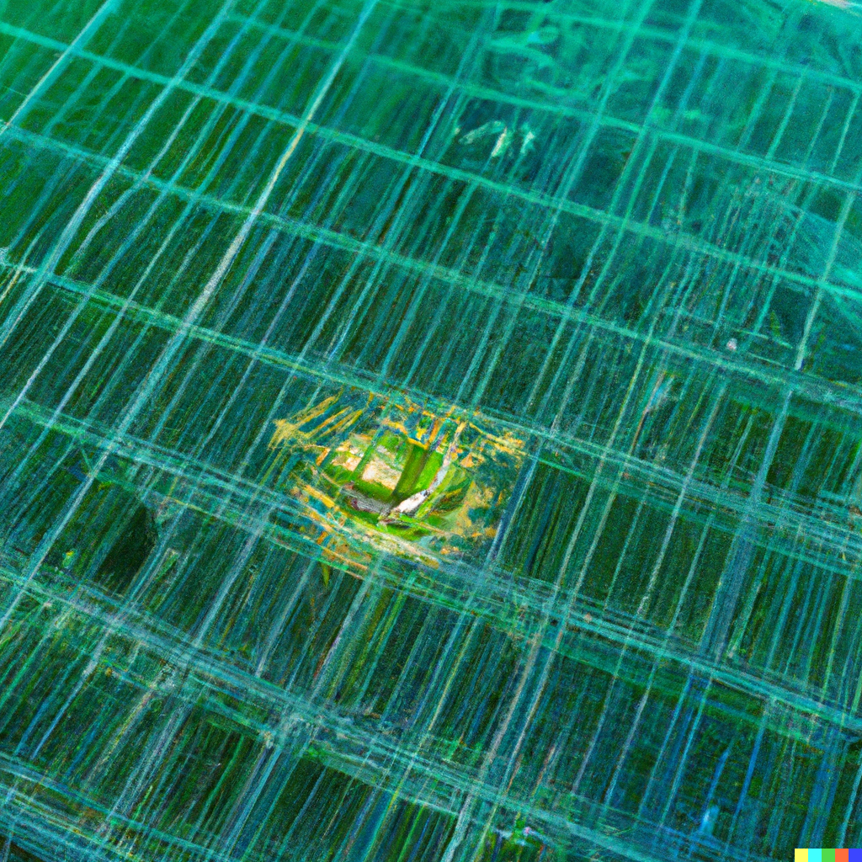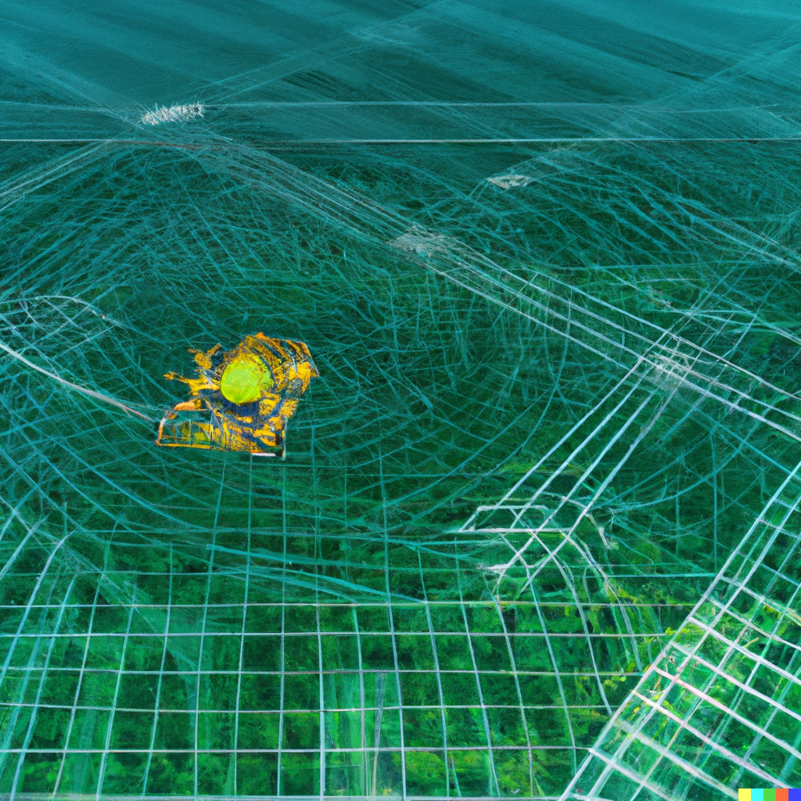

So the whole process of creating these images is taking my agriculture and the metaverse art, or what people are calling the agriverse, and running it through DALLE to quickly gain a background with a painterly quality, and then bring it back to blender adding the drones again to regain the illustrative utility. Which these look more clearly like drones over green crops or at least some agricultural setting in the background compared to the previous image, where the drone was kinda smudged out..

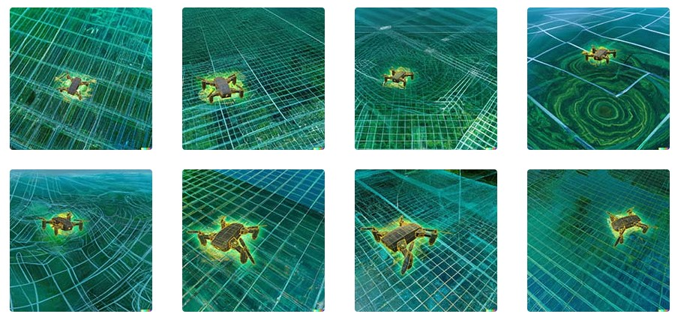

And since the drone is in blender, I thought it would be cool to see it actually in an animation. So here it is hovering with the rotors spinning.

[show animation]

In regards to DALLE being used for illustrations, Peter Lee, the CVP of Research and Incubations at Microsoft, used DALLE images for his latest presentation on CNN (the Cable New Network not Convolutional Neural Networks). Interestingly, MT-NLG's (or the Megatron-Turing Natural Language Generation model’s) explainable AI is referenced inhis presentation. He says, "When we ask the Turing model to explain how it came up with the answer, on its own, it decides to go line by line and give the rationale." I don’t know any other AI that actually gives an explanation of how it finds its results.

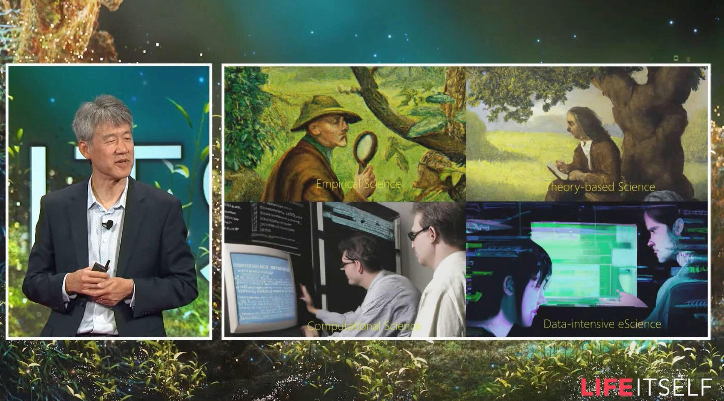

This is an illustration for multi-view video analytics systems inspired by the work of Vijaykrishnan Narayanan in the area of computer vision. For a multi-view video distributed video analysis, the main focal point here is the robotic eye camera against a wall of video displays where the aggregate starts to form a picture. I was trying to imagine what the computer sees. And then I also overlaid a diagram with the idea of Vijay's formula for important feature recognition from his AIoT workshop.

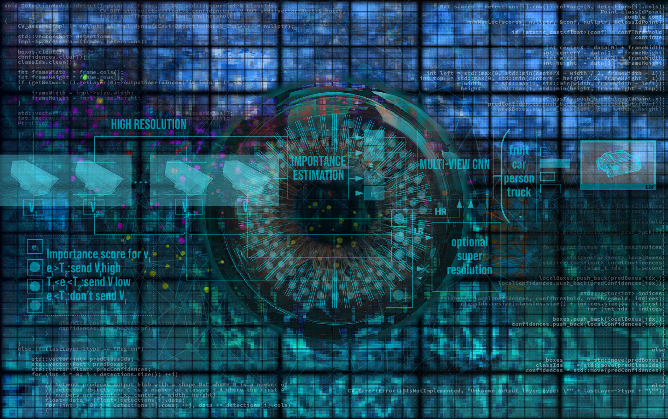

And what’s also interesting was his work on smart gloves that help vision challenged people. This illustration shows the view of the user with an overlay showing the wireframed glove and the formulas from the paper regarding the research.

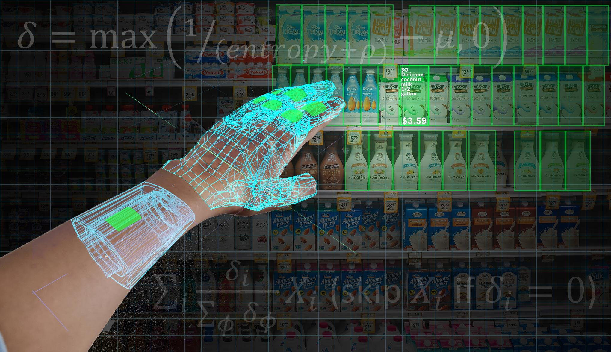

Back to blender and photoshop, this is an image conveying the idea of a self-driving car in a night scene, with the suggestion of a city on the horizon. So just using a wireframe of the car and the representation of sensors and the range of the sensors consisting of binary data. With self-driving cars, they bring in so many different areas of our culture, politics, humanity, and the emergence of typical ethical dilemmas that show the importance of ethics in the development of technologies. For example, you probably know the example of an autonomous car with broken brakes going at full speed towards two pedestrians. Both pedestrians are in danger, but by deviating a little, one can probably be saved. These ethical dilemmas become more prevalent as AI becomes more general. It should be noted that we are part of a company that is actually committed to the advancement of AI driven by ethical principles that put people first.

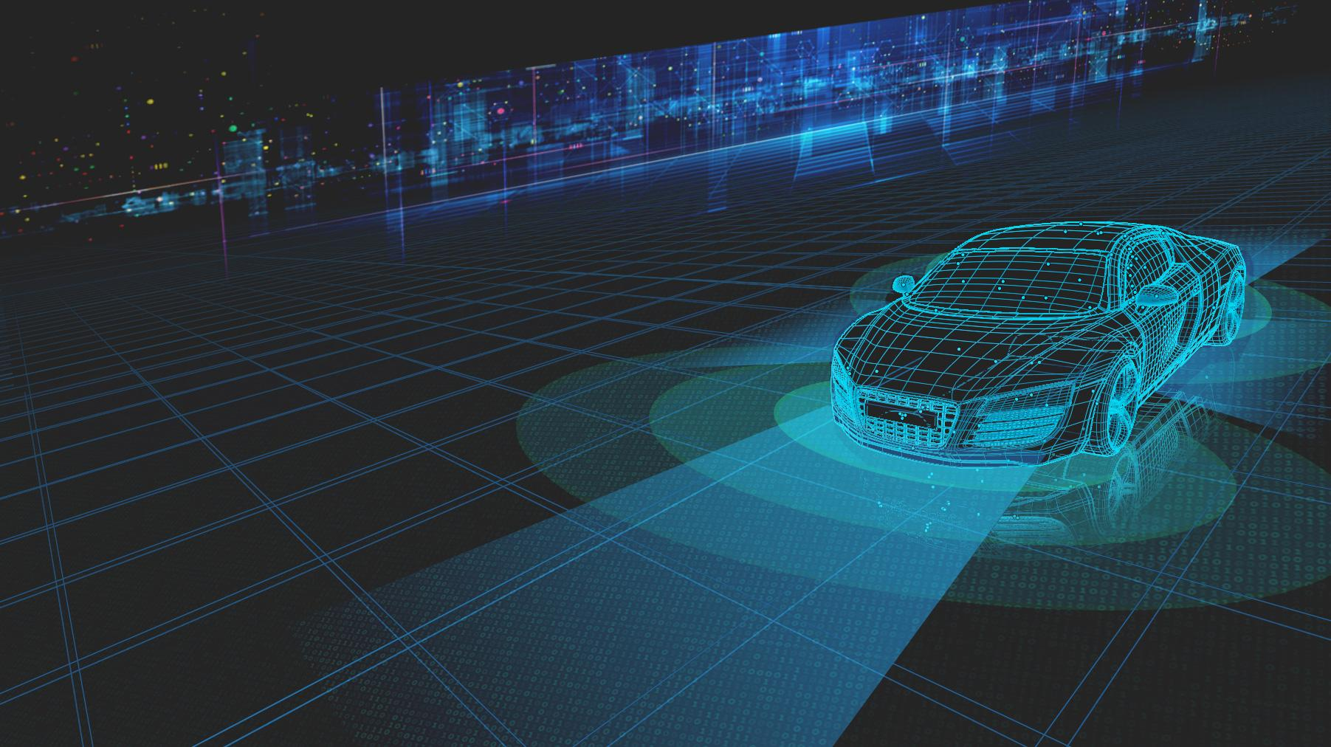

Here is my illustration for AIOps relating to predictive maintenance showing how across time, we can detect, diagnose, and predict. You can see the car identified in the back as a past state with its history of data, then in the middle, in the present we can diagnose the properties of its existence right now, for example the tire condition with the exploded view in lime green showing the data points for each wheel, and then the predicted future state based on what we know from the current state and the historical analysis. To reinforce the idea of time, I literally put clocks on the floor. I also overlaid a neural mesh across the floor as well as code on the left.

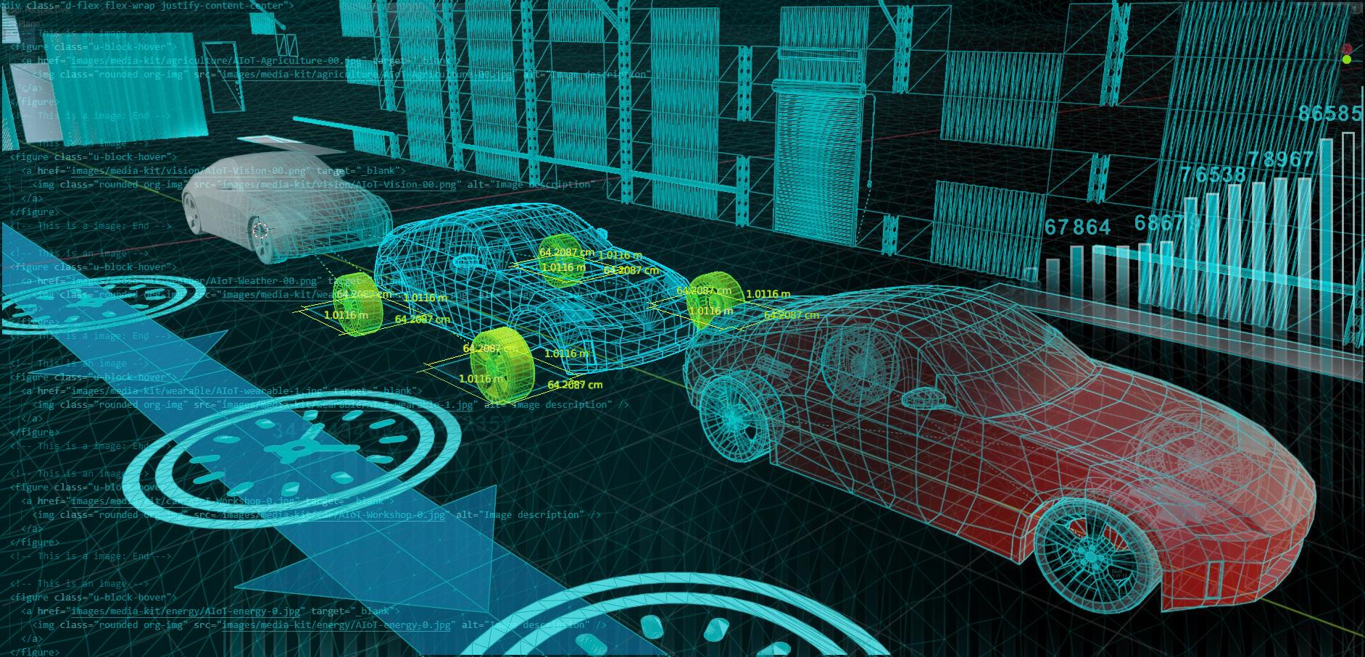

Through that digital twinning, we can also apply that to accessories, clothes, and luxury items, we can know the future of these items while owning the digital representations of the items that can be used in the metaverse.

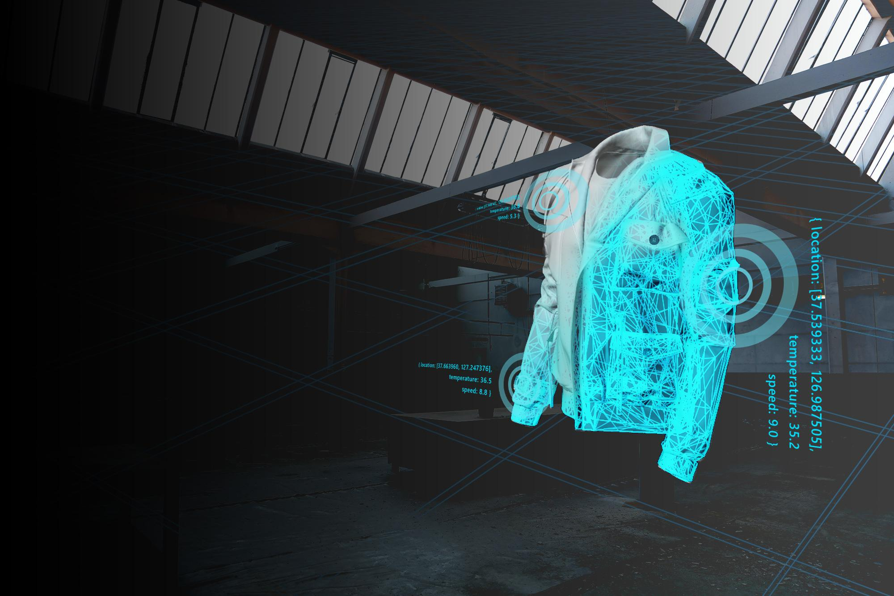

[show animation]

#FashionHacking at Microsoft is a thing right now within the Fashion@Microsft community. (and also being done by well known luxury brands like Gucci) Through analyzing the existing properties or through data collected by sensors embedded in the smart clothing, and then projecting that idea into the future, like we did with the car, by using AI, which can be used to quickly show us what that future could look like for that particular item,

In regards to art and fashion, here is a fashion illustration from 1973 by the French designer André Delfau. You can see the woman wearing a dark red halter top dress with black wrap.

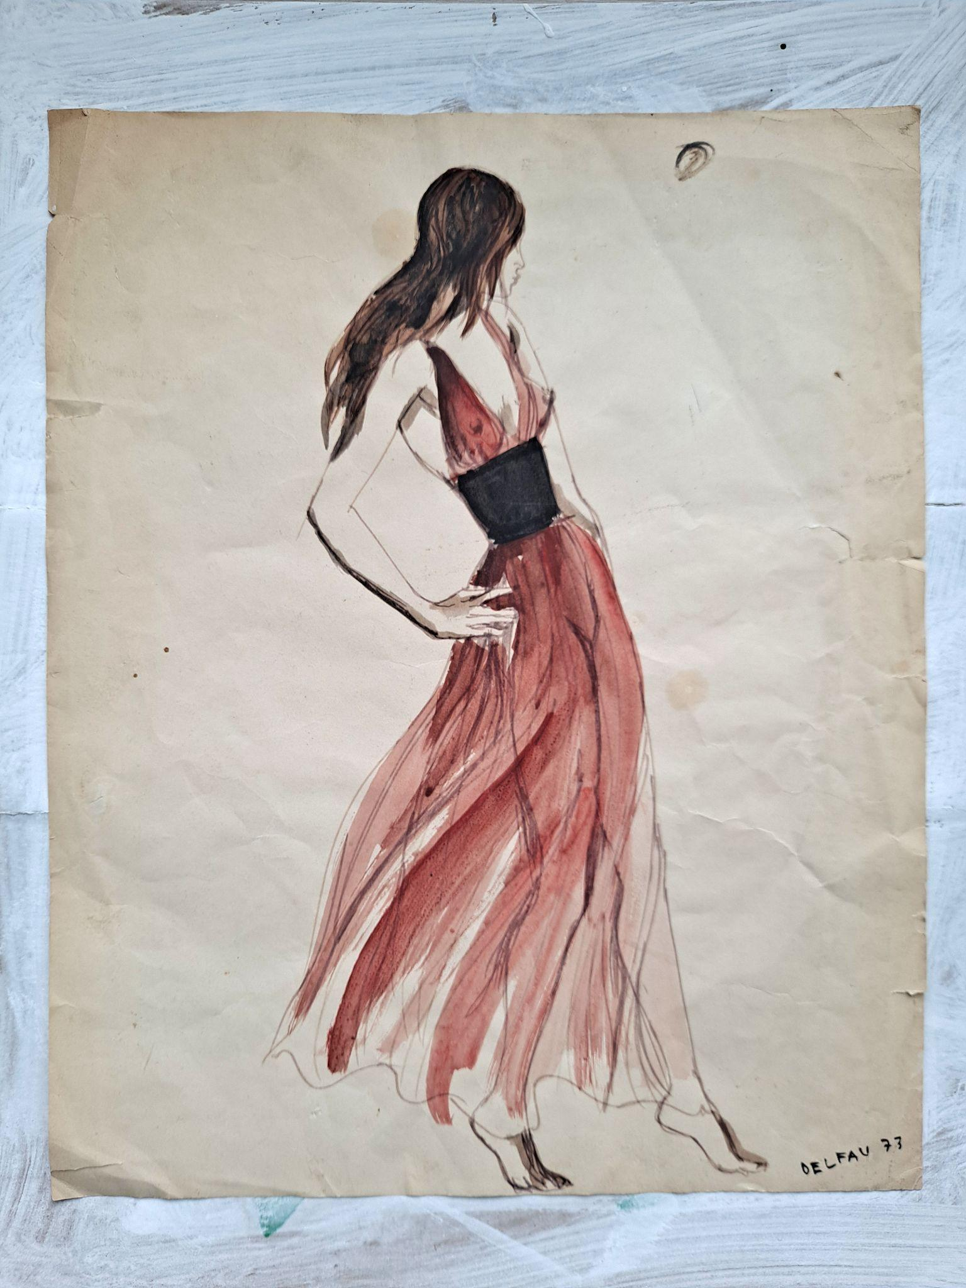

And in this example for Delfau’s fashion design of the red dress. These illustrations were generated by our AI called DALLE based on the previous physical illustration, more variations of this dress can be created. In the first variation, you can see DALLE gave us what the back of the dress would look like which was not shown in the original illustration. In the next one, the top is completely different, and then in the last one you can see that DALLE extends the black of the wrap into these descending stripes.

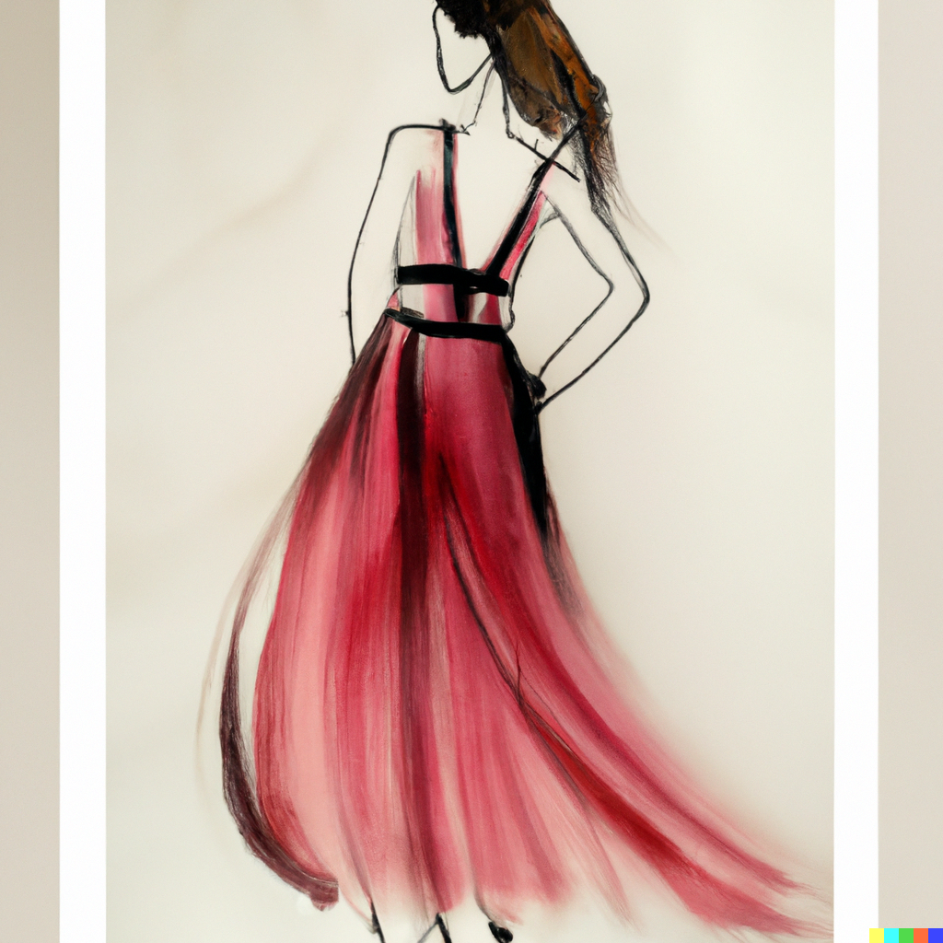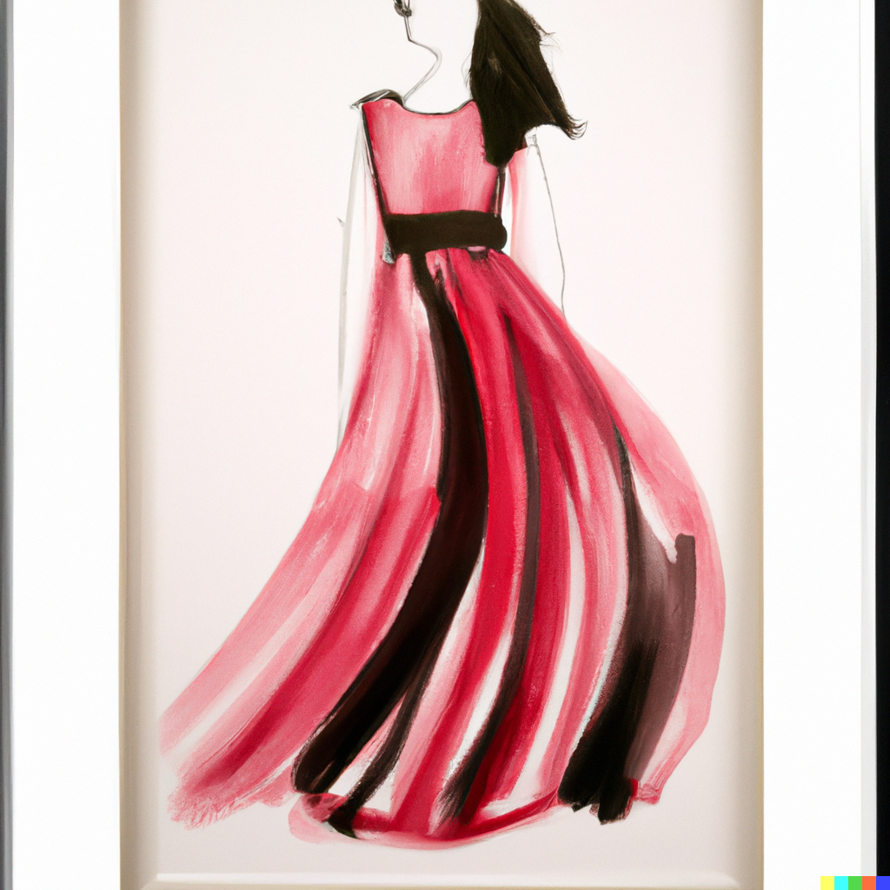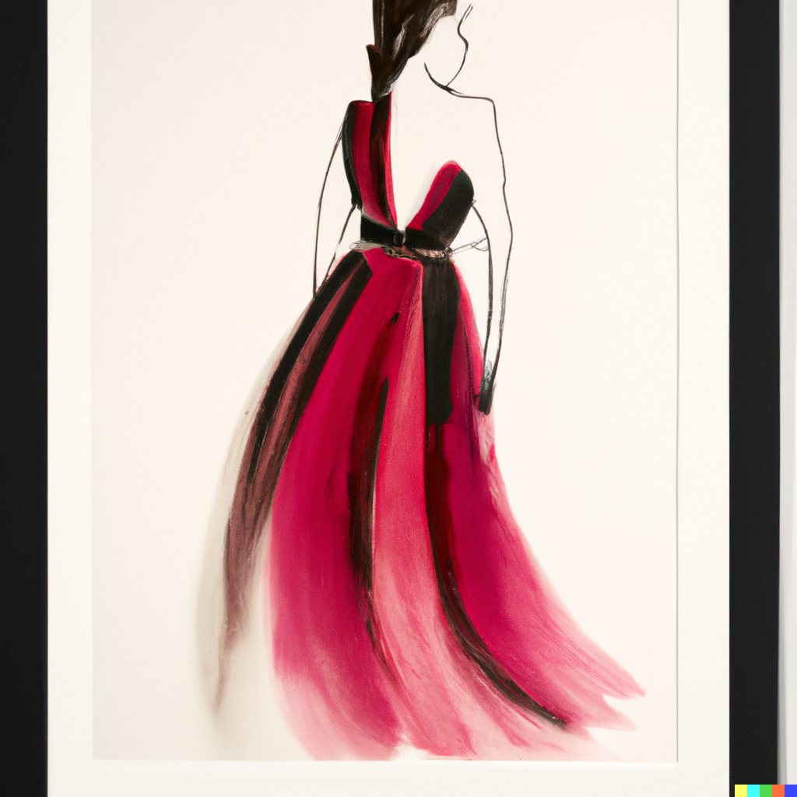

What I understand of what smart cities are is where there is effective integration of physical, digital and human systems to deliver a sustainable, prosperous, and inclusive future for the people who live and work in those cities. Smart cities optimize the use of technology in the design and operation of infrastructure and buildings in a way that meets the current and future needs of their citizens. This is an illustration for MLSys2022 AIOps Workshop. This is a generative work, from code written in python, that shows, again an infinitely scalable landscape, as was in the agriverse illustration, this time with buildings which visually adheres to the principle of design using variety within repetition. You can see the commonality of the buildings on the x and y axis and then the variety being the height, or the z axis. And then having the viewpoint from above, gives a sense of control, or at least an overview, giving a better understanding of the city as an entity in itself.

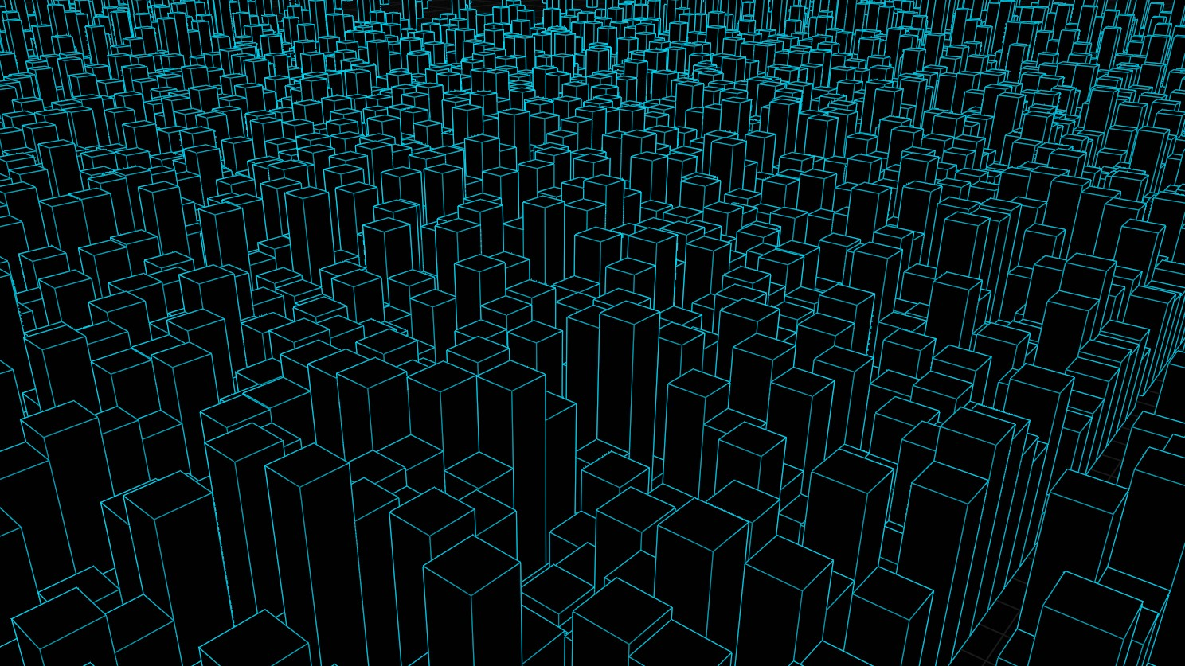

Adding a material to the previous building forms including giving 20% randomly a blue transparent glass. This way, I’m imagining a cloud, without literally showing the representation of a cloud, but more of what we mean, when we talk about the cloud. A pervasive omnipresent cloud of data that is all around us.

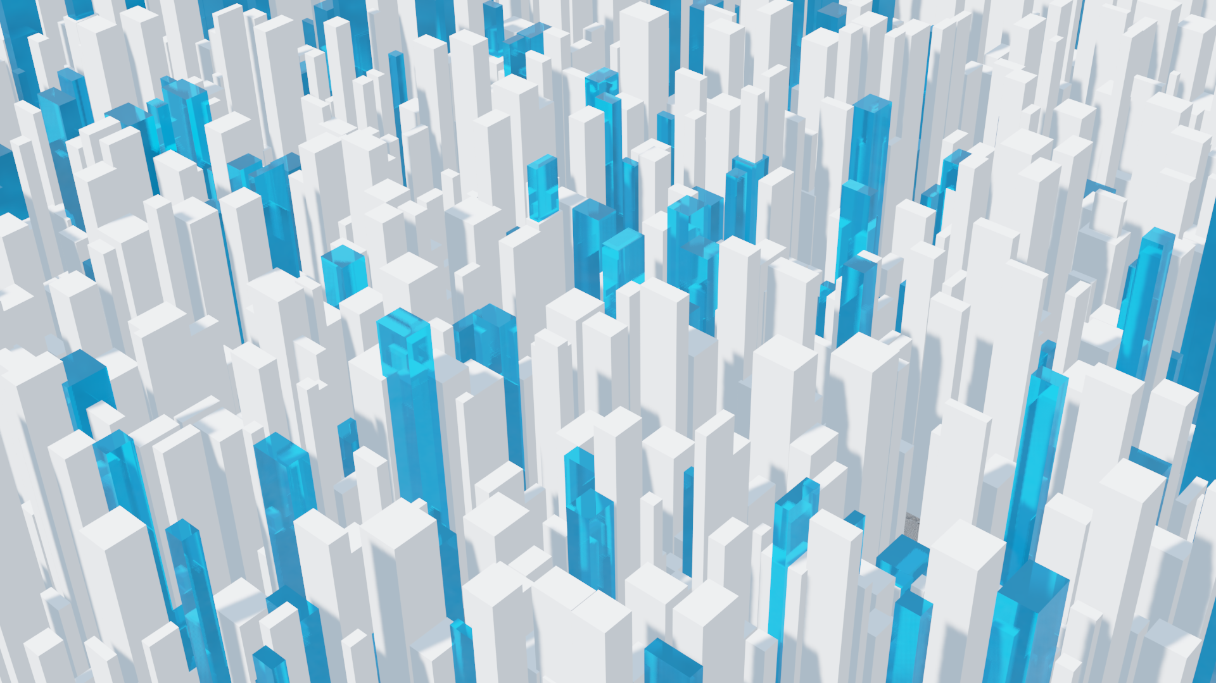

So, taking that imagery along with the content of the workshop, and then using that imagery in designing a brochure, this is a proposal for a tri-fold printed physical brochure that can be handed out at conferences.



I took the image of the smart ciy and directed the AI tool Midjourney to imagine with the prompt, a high-tech city, futuristic, view from above, glass buildings, transparent blue glass towers, white skyscrapers, rectilinear, daytime, realistic, and this is what it gave me. I think this is a great starting point to create an aesthetically pleasing image that will speak about smart cities.

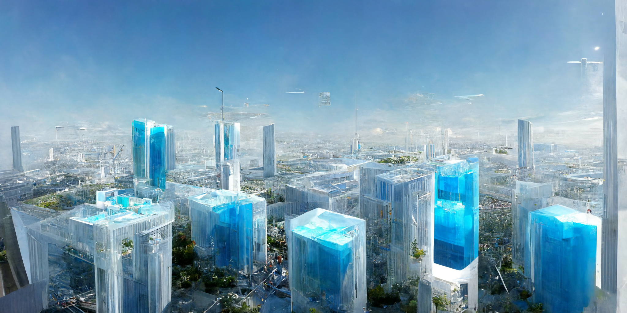

I took the previous image as a base for midjourney to see what it does with a new version of their system and told it to render it in a more photorealistic style, and it gave me this new image and also in more of a night scene.

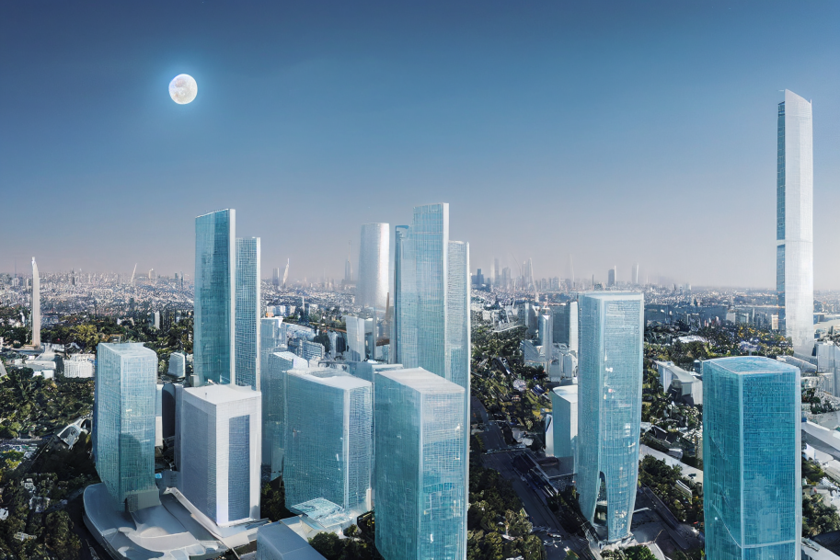

More with AI generating images, you probably are familiar with Vermeer’s painting of Girl with a Pearl Earring..

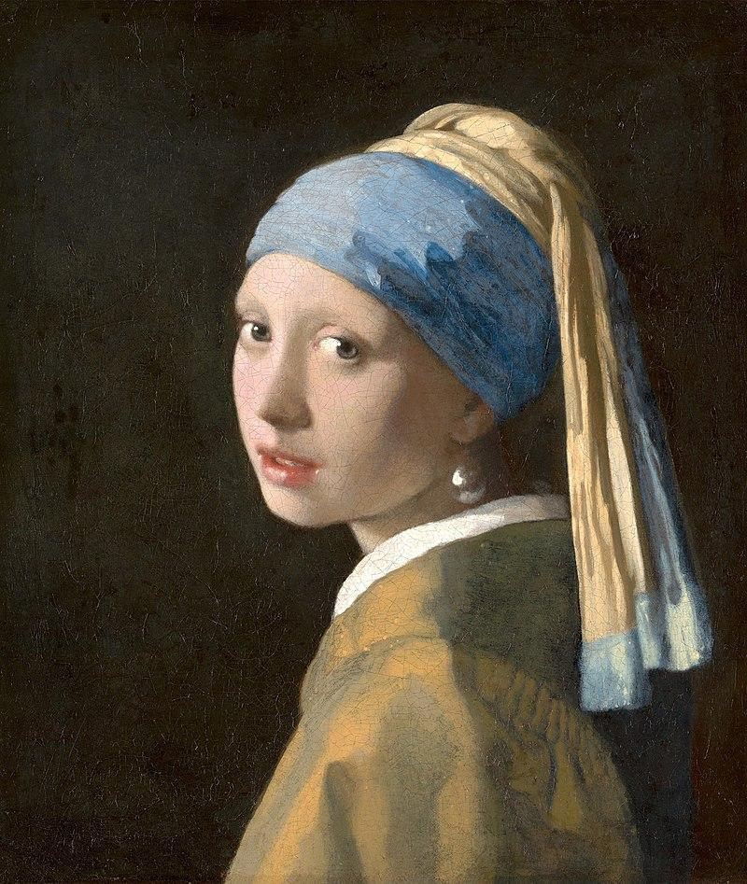

So, one of the features that DALLE has is called outpainting, where it can extrapolate the image, and where we can extend the original image, creating large-scale image in any aspect ratio. Outpainting takes into account the image’s existing visual elements — including shadows, reflections, and textures — to maintain the context of the original image.

[show animation]

And this is an outpainting showing an expanded view of the scene. So the AI identified the style and expanded the interior area, giving it more depth, and filling it with a multitude of objects.

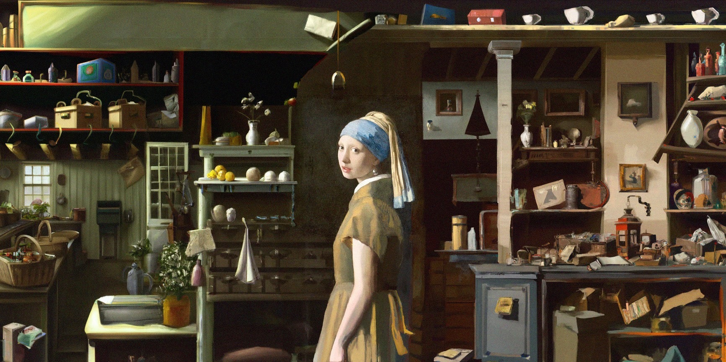

So what I did was I took the previous smart city and outpainted that, giving a more larger scale vast city, which I did here. What I thought was interesting without any specific input is that DALLE added a little waterfront shown down here with a boat.

[show video]

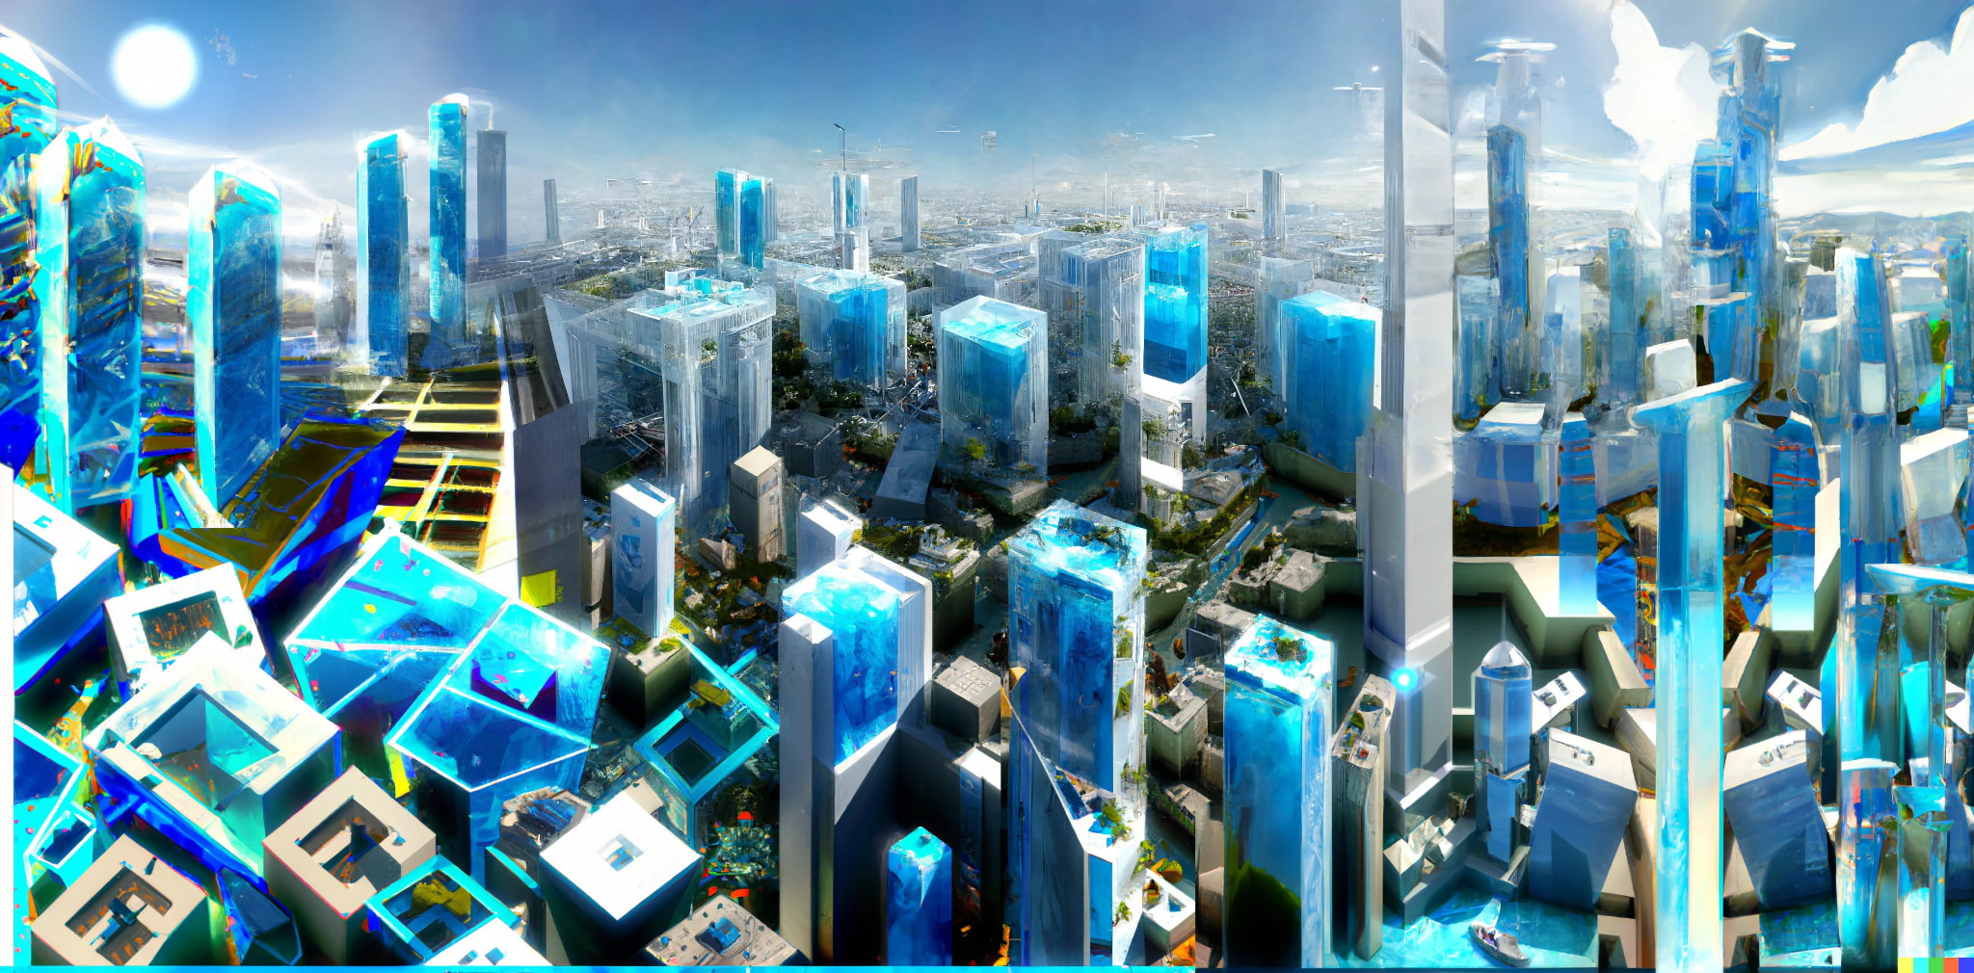

Back to photoshop and blender, here is an illustration for space which is really taking off right now, including Azure Space or compute in space, which I was inspired by the paper Shadi Noghabi wrote recently researching real-time monitoring from satellites. Noghabi’s research talks about enabling real time earth observation from space by reducing the time of data transfer from satellites to data centers. The drive is to significantly reduce cloud workloads on satellite imagery.

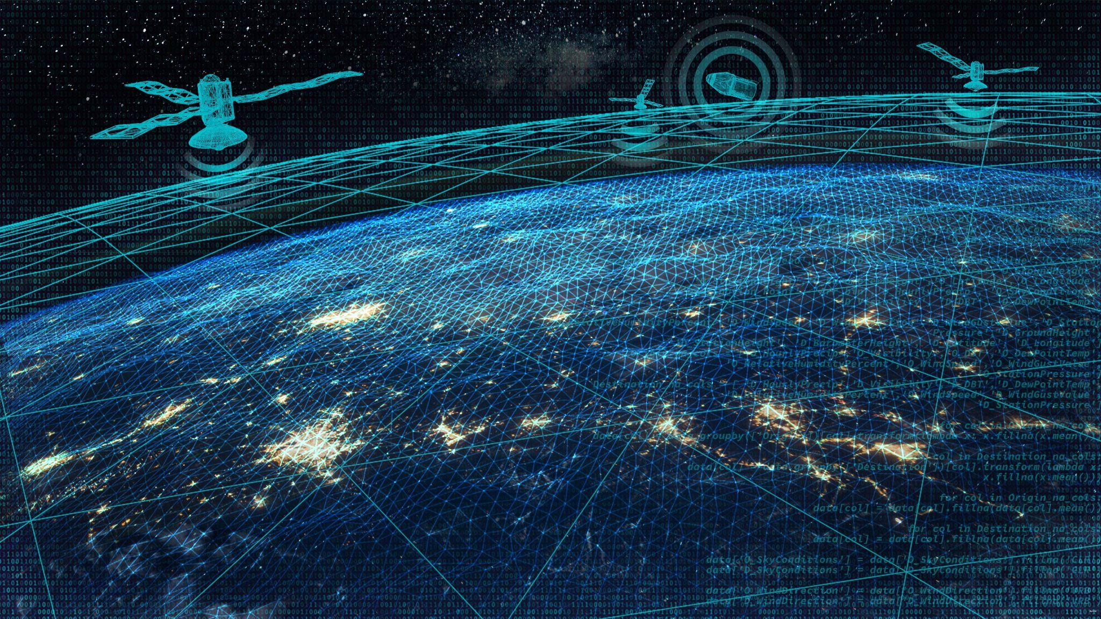

So, I then went back to photoshop and to make an image speak about smart cities **as well as** space, combining the two previous images of the city and space. So we’re looking down on the smart city with a moon in the sky and the low earth orbit network of satellites. Right now, Azure Orbital co-locates Microsoft ground stations in Microsoft datacenters or in close proximity. In addition, Azure Orbital enables customers to use partner **ground stations** to ingest data in Azure using those **ground stations**. So I’m guessing that AIOps can improve either the compute work that the ground stations have to do by having the satellites take on some of that work and/or speed up the analytics view to real time, which was mentioned by Noghabi.

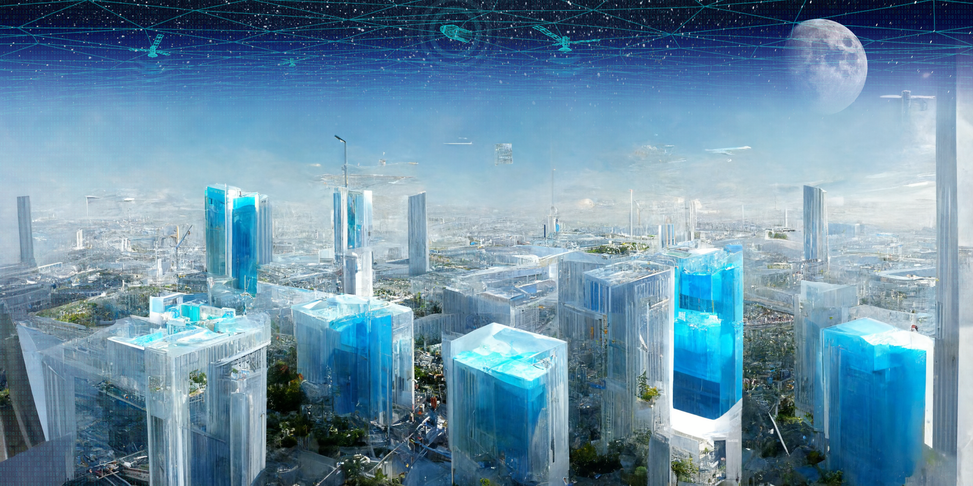

So what will that look like? Here’s an illustration of weather prediction with remote weather sensing stations. There’s these public bus stops in the neighborhood that I live in that have these sensors attached to them that gather data. And then I took a photo of one and built on the photo by showing clouds with overlays of data, a neural mesh, code, and topography. And incidentally, this code is open source used for weather prediction. So this is ending back on the vision of literal clouds.

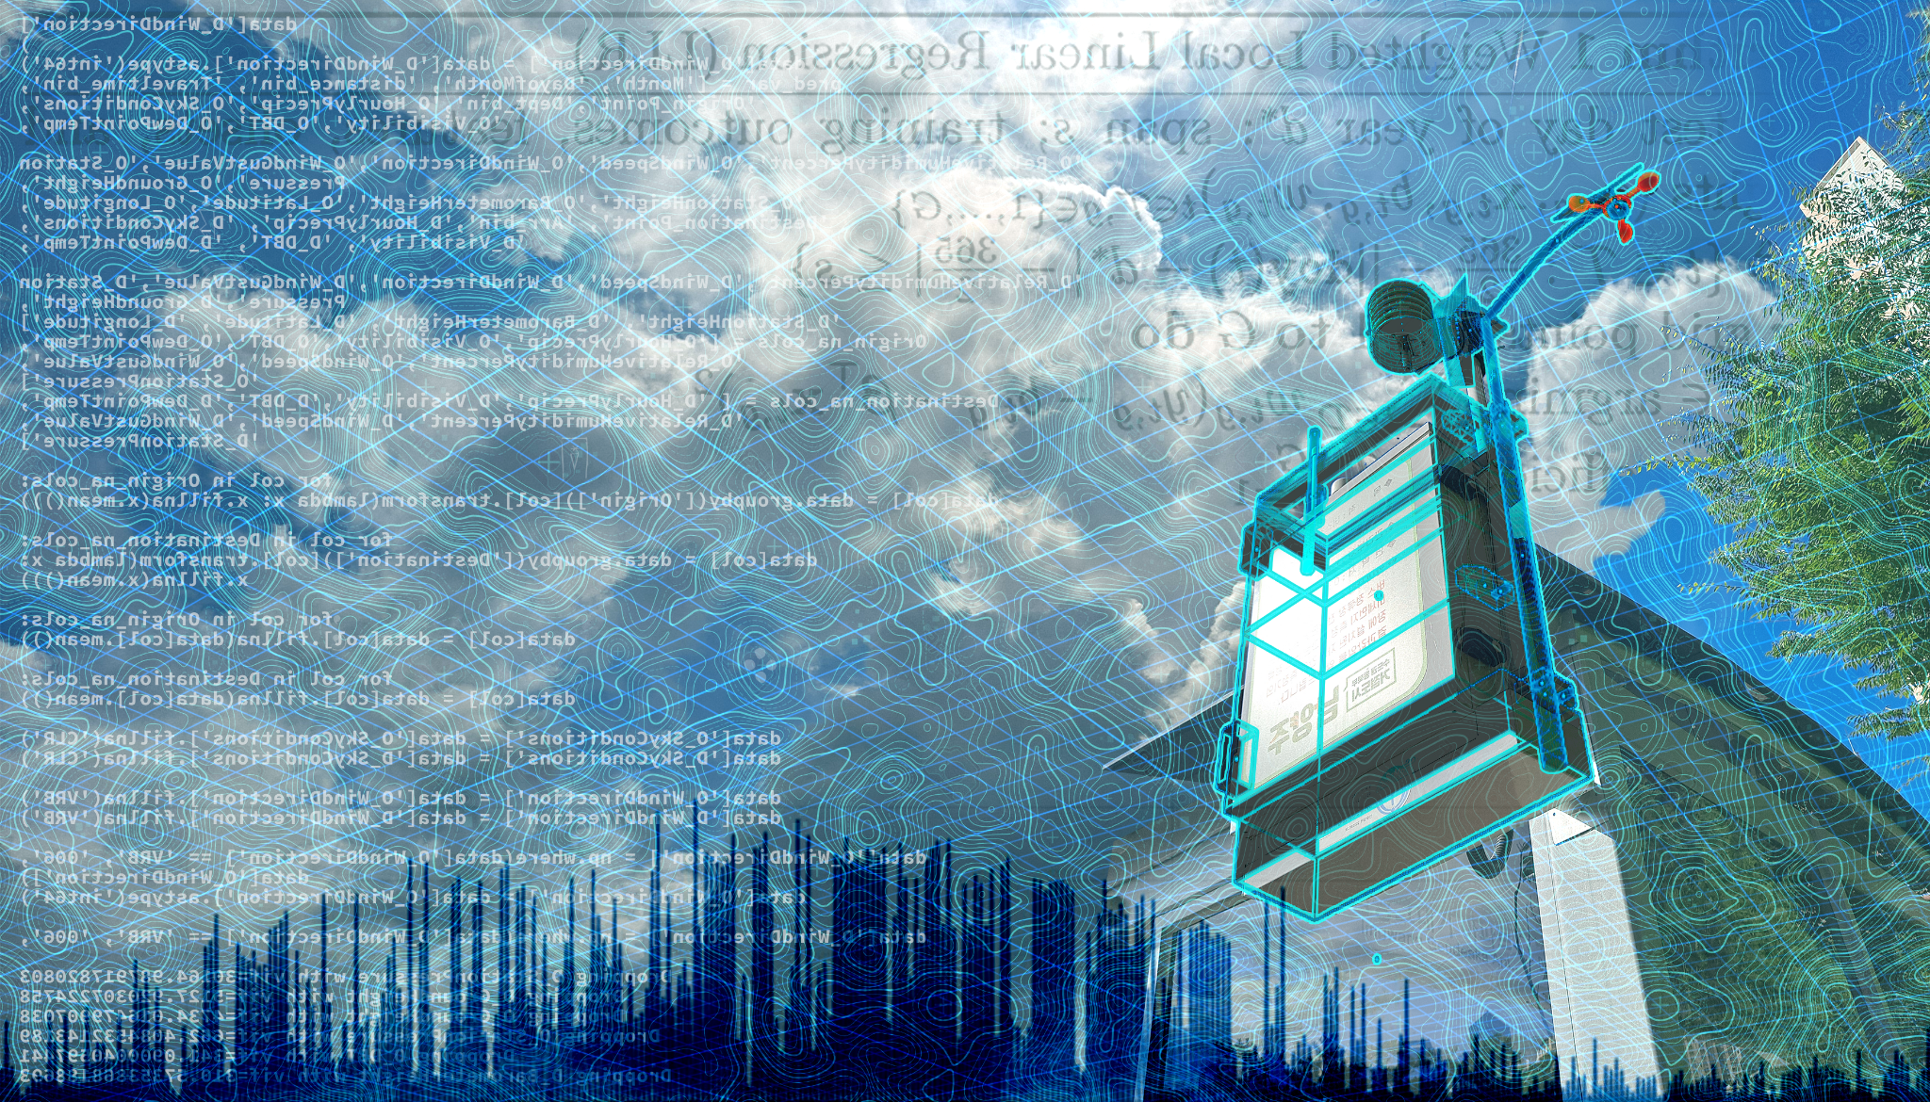

So what will the Cloud Intelligence / AIOps workshop hero look like for 2023? I recently saw a work by the artist An Te Liu where a cloud was created with a number of air conditioning devices which I thought was interesting regarding climate.

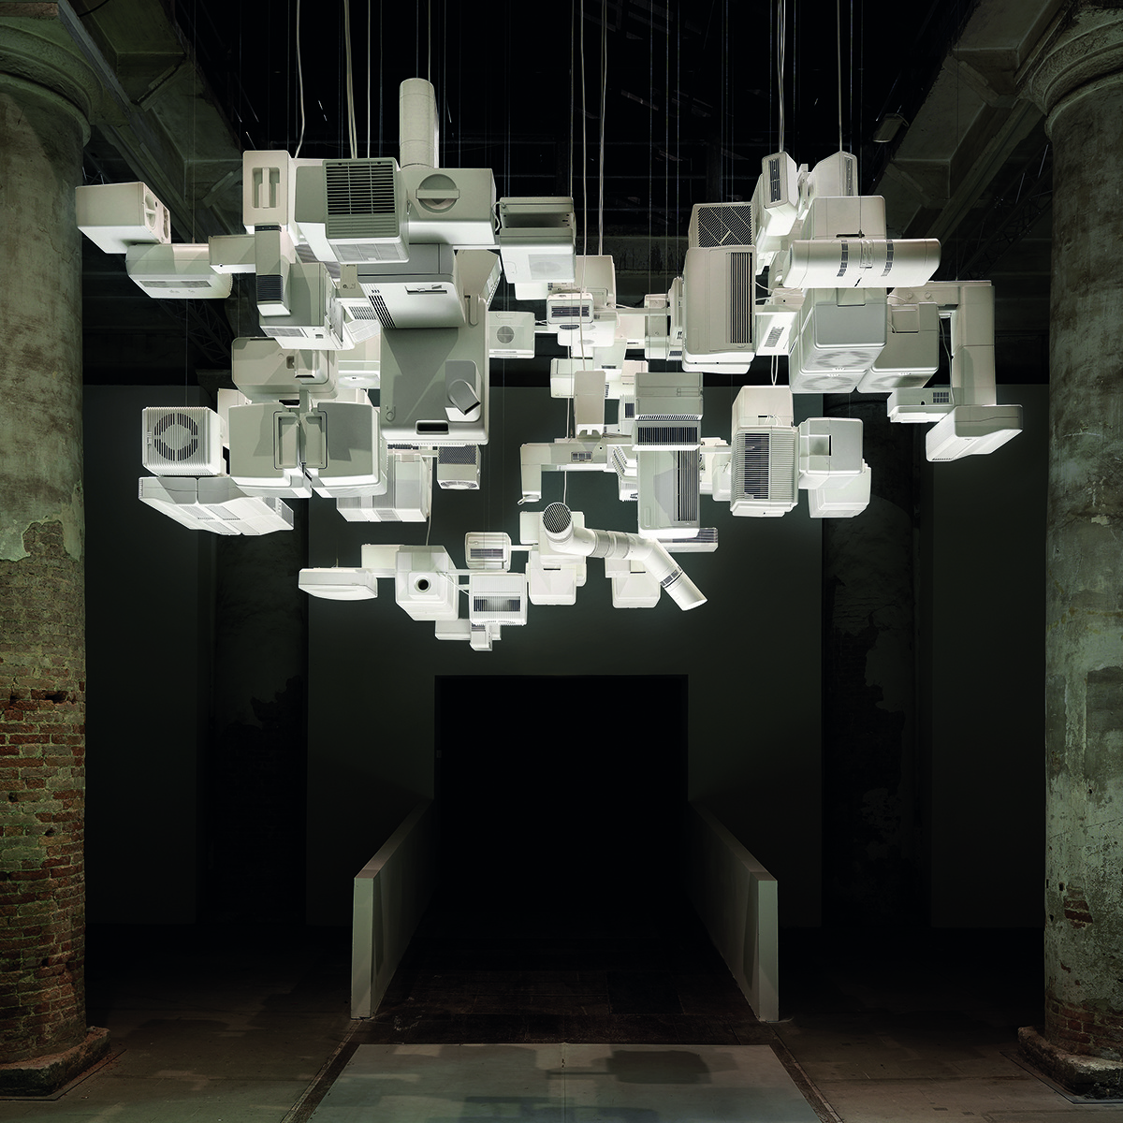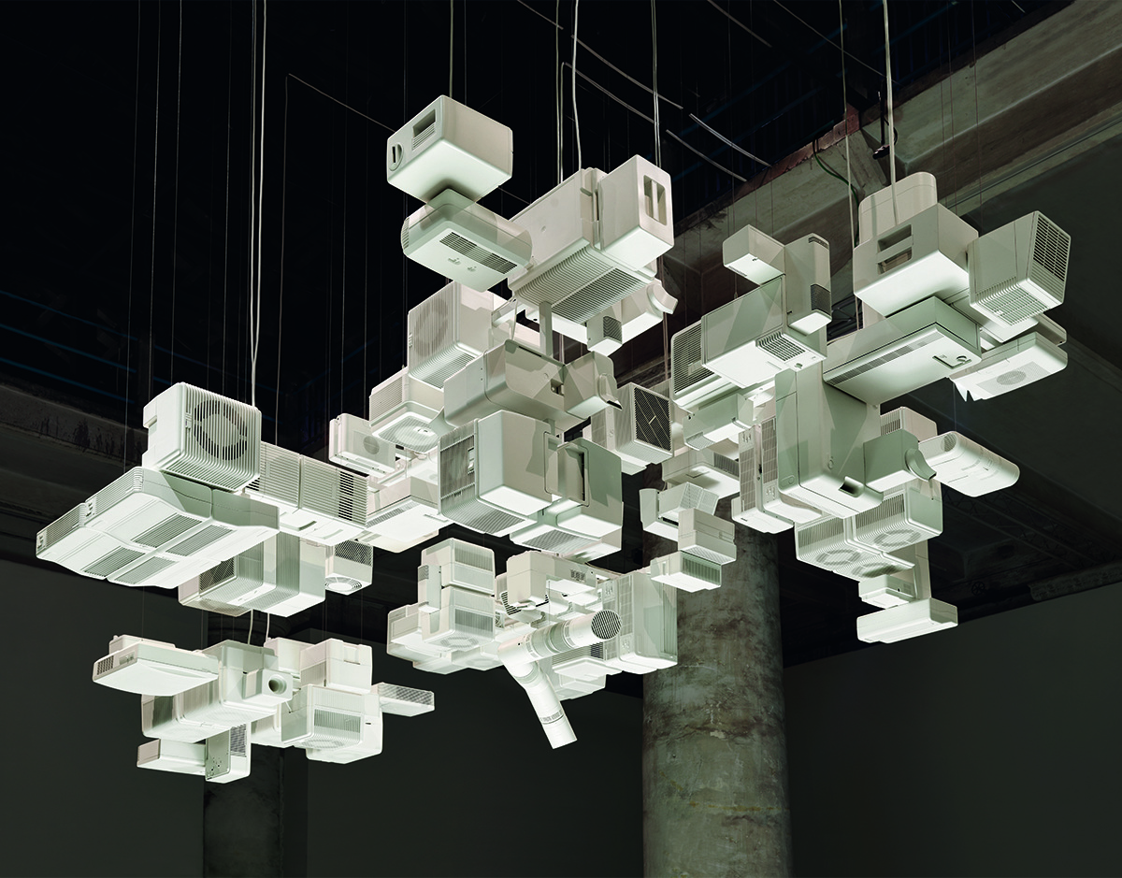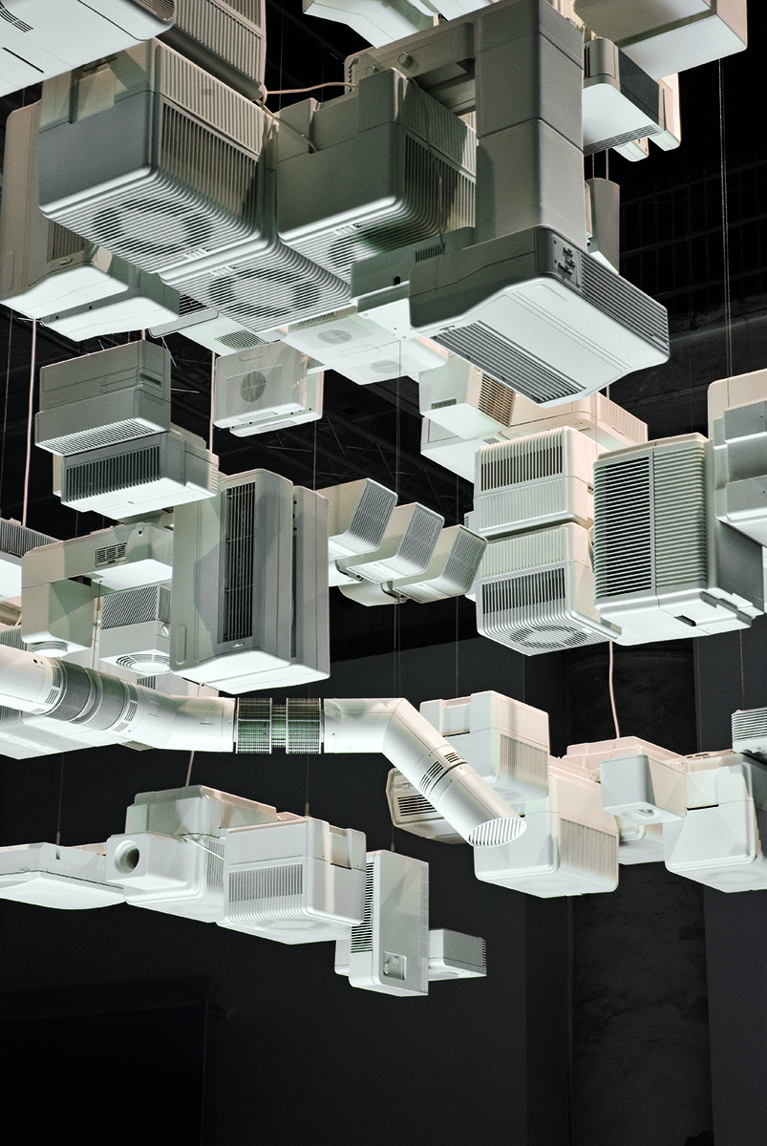

A possibility is creating digitally a 3D cloud in the lines of Liu but where the devices forming the cloud are all the devices that use the cloud from like phones to refrigerators and everything in between. And since next year will be in Melbourne, show that cloud above Melbourne as a smart city, with maybe the vision of science fiction with a spaceship in the sky, shaped somewhat like a kangaroo ready to use a jump gate.

***